

Write your name below:

_______________________________________________

**Hale School**

**Year 11 Semester 2 Examination, 2015**

**Mathematics   
Methods**

**Teacher:__________________________**

**Section Two:  
Calculator-assumed  
  
Booklet 2 of 3**

TIME ALLOWED FOR THIS SECTION

Reading time before commencing: Ten minutes  
Working time for paper: One hundred minutes

**MATERIAL REQUIRED/RECOMMENDED FOR THIS PAPER**

*TO BE PROVIDED BY THE SUPERVISOR*

**TWO** Question/Answer booklets for Section Two – complete BOTH.

Formula Sheet (retained from Section One).

*TO BE PROVIDED BY THE CANDIDATE*

*Standard Items*: pens (blue/black preferred), pencils (including coloured), sharpener,   
 correction fluid/tape, eraser, ruler, highlighters

*Special Items*: drawing instruments, templates, notes on one unfolded sheet of A4 paper, and   
 calculators approved for use.

**IMPORTANT NOTE TO CANDIDATES**

No other items may be taken into the examination room. It is your responsibility to ensure that you do not have any unauthorised notes or other items of a non-personal nature in the examination room. Please check carefully, and if you have any unauthorised material with you, hand it to the supervisor **BEFORE** reading any further.

**STRUCTURE OF THIS PAPER**

|  |  |  |  |  |  |
| --- | --- | --- | --- | --- | --- |
| Section | Number of questions available | Number of questions to be answered | Working time (minutes) | Marks available | Percentage of exam |
| Section One:  Calculator-free | 7 | 7 | 50 | 50 | 33 1/3 |
| Section Two:  Calculator-assumed | 12 | 12 | 100 | 100 | 66 2/3 |
|  | | |  | **Total** | 100 |

**INSTRUCTIONS TO CANDIDATES**

1. Write your answers in this Question/Answer Booklet.
2. You must be careful to confine your responses to the specific questions asked and to follow any instructions that are specific to a particular question.
3. Spare pages are included at the end of this booklet. They can be used for planning your responses and/or as additional space if required to continue an answer.

● Planning: If you use the spare pages for planning, indicate this clearly at the top of the page.

● Continuing an answer: If you need to use the space to continue an answer, indicate   
 in the original answer space where the answer is continued, i.e. give the page number.

1. Fill in the number of the question that you are continuing to answer at the top of the page.
2. Show all your working clearly. Your working should be in sufficient detail to allow your answers to be checked readily and for marks to be awarded for reasoning. Incorrect answers given without supporting reasoning cannot be allocated any marks. For any question or part question worth more than two marks, valid working or justification is required to receive full marks. If you repeat any question, ensure that you cancel the answer you do not wish to have marked.
3. It is recommended that you do not use pencil, except in diagrams.

**Section Two: Calculator Assumed 100 marks (66 2/3 %)**This section has 12 questions. Answer all questions. Write your answers in the spaces provided.  
Working time: 100 minutes  
_______________________________________________________________________________

**Question 8 6 marks**

A drilling company is digging a hole so that hot water can be brought to the surface to heat a swimming pool. On Day 1 they dig down 8 metres and as the hole gets deeper the distance that they dig reduces by 20 centimetres each day.

* 1. Write down the distance that they dig on each of the first 4 days. (1 mark)

1. Calculate the distance that they dig on the 20th day. (1 mark)

c. On which day do they stop digging? (2 marks)

d. How deep is the hole that they dig? (2 marks)

**Question 9 9 marks**

A window frame is to be made as shown.

The frame consist of 3 vertical and 4 horizontal

metal struts and a semicircular arc on top.

The window needs to be constructed so that

the total area is 6 square metres.

a. If each vertical strut is of length h metres and each horizontal strut is of length 2r metres, show that  (2 marks)

b. Find a formula for the total length of metal used in terms of r. (2 marks)

**Question 9 (Cont)**

c. Use calculus to find the value of r, correct to 2 decimal places, that minimises the total length of metal justifying that the amount found is indeed a minimum. (4 marks)

d. State, in metres to 2 decimal places, the minimum length of metal required. (1 mark)

**Question 10 5 marks**

Show from first principles that the derivative of the function  is .

**Question 11 6 marks**

The graph below shows the height h (in metres) against the time t (in seconds) for a lift that ascends 40 metres from one stop to another.

h

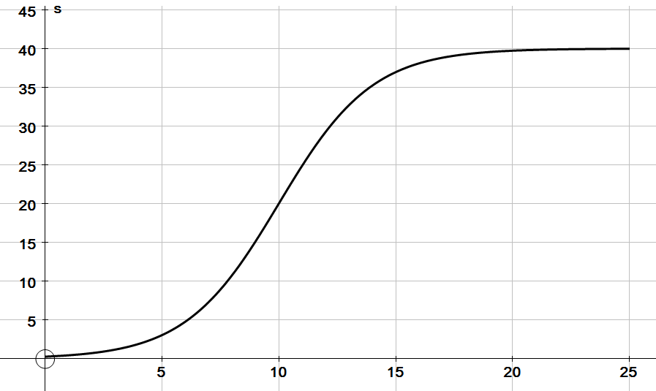

t

a. Use the graph to estimate the velocity of the lift when it has reached a height of 30 metres. (2 marks)

b. Use the graph to find the time at which the lift is moving at the fastest speed? (1 mark)

c. On the axes below draw the sketch of the velocity of the lift against time. (3 marks)



**Question 12 7 marks**

A drug is administered to a patient and the concentration of the drug in the bloodstream at time *t* after the drug has been administered, is given by  where *C* is measured in mg/L and *t* is in hours.

1. If this model applies for the time period , state the appropriate value of *T* so that the model makes sense. (1 mark)
2. Determine the average rate of increase in concentration over the first 4 hours. (2 marks)
3. Determine the instantaneous rate of change of the concentration after 4 hours.

(2 marks)

1. At what time is the concentration falling most rapidly? Show working to explain your answer. (2 marks)

**Question 13 9 marks**

An arithmetic sequence has a 3rd term of 132 and a 7th term of 120.

Find

a. The first term and the common difference for the sequence. (3 marks)

b. The sum of all the positive terms of the sequence. (3 marks)

c. Find the number of terms for which the sum of the sequence is 2415. (3 marks)

**Question 14 8 marks**

Consider the polynomial function . The graph of  has a gradient of -18 at the origin, (0, 0). It also has turning points at x = 3 and x = -1.

a. Determine the values of a, b, c and d. (6 marks)

b. Find the exact value(s) of x at which the gradient is equal to -6. (2 marks)

**END OF BOOKLET 2**

This page may be used for extra working space:

Question: ______

This page may be used for extra working space:

Question: ______